PANAMUN XXXI
Empowering Tomorrow's Leaders

FIFA SPECIAL COMMITTEE
Delegate Handbook
International School of Panama
October 25-27, 2023

- INTRODUCTION

Welcome to the PANAMUN Fédération Internationale de Football Association (FIFA).
We’re so glad you applied to be part of the FIFA committee. On behalf of the entire PANAMUN staff, we hope you enjoy the conference and are able to use this handbook to properly prepare yourself and make sure you get the most out of this experience.

The Fédération Internationale de Football Association (FIFA) is the international governing body of association football. This association was founded in 1904 and its current headquarters is located in Zürich, Switzerland. The organizational Principles of FIFA include a number of goals, such as expanding association football internationally, making efforts to make it accessible to everyone, and promoting honesty and fair play. There are 211 national associations that are members of FIFA who all form part of their respective regional confederations that the world is divided into CONCACAF(North & Central America and the Caribbean) CAF(Africa) UEFA(Europe) AFC(Asia and Oceania) CONMEBOL (South America). The main governing bodies of this organization are the FIFA Congress and the FIFA Council. The Congress is composed of a member of each national member association and makes decisions about FIFA's governing statutes, including how their strategies should be applied and implemented, holds elections, approves the yearly report, and makes decisions regarding the approval of new national associations. The Council is made up of 37 members and it’s chaired by the president. The Council is in charge of making the organization's primary decision-making body between sessions of congress making it one if not the most important branch of FIFA.

The FIFA Committee is not unique to PANAMUN, it rather represents a form of MUN designed to challenge delegates' adaptability and strategic thinking within their areas of interest.

The committee is run by two chairs and overseen by the Deputy Secretary General of Special Committees, Chairs will be in charge of moderating debate, answering crisis notes, and approving directives. During the conference there will also be an admin in the room to ferry notes between delegates and chairs. This committee will be frequented by characters relevant to the topic depending on the issue.

Ultimately, we chose you for FIFA because we see and appreciate your interest, debate skills, and work ethic. To fulfill the correct experience in this committee please take time to prepare for the conference with the following handbook.

- Prior to the conference

Research
- Use your issue bulletin. Use your chair’s bibliography to guide your own!
- Limit your search. Type your search into Google. Click the Settings button, and then click “Advanced search.” Narrow your search in the “site or domain” box by typing in .gov, .edu, or .org. You can also narrow it to un.org to get information straight from the source.
- Start off broad and narrow down. This way you can find new interesting ideas that haven’t been explored and use them to steer debate in an interesting direction!
- Ask your teachers. Your MUN Director, librarians, and social studies teachers will probably be willing to help you. There is no shame in asking for help--researching is a skill you will need for the rest of your life!

Research Binder
Many delegates choose to print their research, organize it inside a binder, and bring it with them to the conference. This practice is extremely recommended, since the conference’s policy prohibits the use of electronic devices, with exception to the first day of the conference when lobbying takes place.

Position Papers
The Position Paper is a one-page essay that outlines your person's view on your issue. You will need to write one for each issue in your committee. Here are some steps:
- Read your issue bulletins!
- Take notes, making sure that you use the guiding questions to help you think about how your person relates to the issue.
- Do more research about your country and how it relates to your issue. Look below at Research Tips to help you begin your research.
- Start writing!

The Position Paper is broken down into four sections:
- Topic Background: this should be a brief summary of the issue that shouldn’t require any extra research. Aim for about 2 sentences.
- Past International Action: How has the world already tried to fix the issue? Aim for 3-4 sentences.
- Country Policy: discuss what your country thinks about the issue.* *How does the person want to fix it--if they even do? This is where you will need to show your research. Aim for 5 sentences.
- Possible Solutions: be creative! How can you solve the issue? Think outside the box! Aim for 3 sentences.
- Bibliography: cite your sources!

The position paper is a one-to-two page document that details your position in the
committee. For the rest of PANAMUN, the position paper is divided into five clear
sections. You do not have to follow this structure, it is simply a suggestion. Please note that if you want an award, you must submit a position paper. You are encouraged to write in first person!

- During the Conference

Procedure
Unlike most of PANAMUN’s committees, FIFA follows North American style procedure. They include moderated and unmoderated caucuses, instead of lobbying. A caucus is the way in which delegates can speak to one another and share their ideas. Your chairs will be flexible with the procedure in order to accommodate any confusion and crises that arise. Here is a general list of motions:
- Motion to open debate. Necessary at the beginning of the conference and after any breaks. Simply allows debate to begin. Your chair will call for it when appropriate.
- Motion to open speaker’s list. At the very beginning of the debate, the chair will call for this motion. It acts as an “opening speech” for the committee. Each delegate will add themselves to the list and will have one minute to introduce themselves to the committee. Commonly, these speeches begin with a greeting, followed by an introduction to the character and their general intentions for the debate.
- Motion for a moderated caucus. This is used to suggest topics for the committee to debate. Each delegate may speak when the chair asks for speakers. Delegates speak one at a time, trying to fill the allotted time per speaker, until the time for the caucus has elapsed. The delegate who proposes the caucus will have the choice to speak first or last. There are no questions, unless they are asked during a delegate’s speech. The delegate who proposes the caucus must state the topic, the total time (a maximum of 20 minutes), and the time each speaker will have (minimum 30 seconds, max 60). Note that the total time for the caucus must be divisible by the speaking time. For example:
- There cannot be a caucus of 8 minutes and 30 seconds if each speaker has 60 seconds.
- If the speaking time is 45 seconds per speaker, the total time must be divisible by 45 seconds--6 minutes, 9 minutes 45 seconds, 13 minutes and 30 seconds, etc.
- Motion for an unmoderated caucus. This is used when delegates want to discuss without the constraints of moderated caucus procedure. This time can also be used to lobby and write directives. Delegates who propose this motion must state the time for the “unmod” (maximum of 20 minutes). Chairs play no role besides stating how much time is left and being available for questions.
- Motion to extend current caucus. Used if a delegate believes the current (un)moderated caucus is productive and needs to be extended. The chairs may not always accommodate this, either because they believe debate has entered a rut or due to time constraints. Delegates must state the duration of the extension.
- Motion to introduce (a) directive(s). Directives are the crisis version of resolutions. Directives contain a list of actions that the committee deems appropriate for the situation. Please write the name of the directive, the main submitter(s) names (no more than two), and the signatures of at least ⅔ of the committee. Signing only means the delegate wants to debate it. Actions should be numbered; full sentences are not always necessary. All actions should be specific, including troop numbers, funding amounts, etc. when necessary. The chair will read out the directive once it has been introduced. Examples of what a directive may include:
- Issuing a press release on the state of the committee
- Issuing commands to the army or any other governmental bodies.
- Condemning actions/declaring laws
- Sending committee-wide letters to other (members of) governments
- Any other actions the committee deems necessary.
*Note that any delegate may introduce any directive, regardless of who is the main submitter. Delegates can also opt to introduce, read, and vote on multiple directives at once.
- Motion to suspend/close debate. Used to end debate, usually before a break and at the end of the conference. The chair will call for this motion when appropriate. Points are simply questions a delegate may have. A delegate may ask any questions related to the committee and/or conference, including:
- Going to the bathroom
- Adjusting the room temperature
- Time to breaks/time left
- Procedural questions
- Any questions about the actual issue, whether that be the historical time, situation, and updates, etc.

Flow of Debate
Chair: Can I get a motion to open debate?
Any delegate: *raise placard* Motion to open debate.
Chair: Debate has now been opened. As we are just beginning debate, the chair asks for a motion to open the speaker's list.
Any delegate: *raise placard* Motion to open speaker’s list.
Chair: That is in order. All delegates wishing to add themselves to the speaker’s list?
All delegates: *must raise placard*
Please note that you will be added to the speaker’s list in the order that the chair sees your placard. All delegates must raise their placards.
Chair: Okay, thank you. We will begin with A. You have the floor for one minute. I will tap the gavel once at 45 seconds and twice at 60, which means you must finish your sentence.
A: *Stands up and gives a speech. Sits down when finished*
Chair: Next is Y.
Y will give their speech, and so on, until everyone has given their speech.
Chair: With that, the Speaker’s List is exhausted.
[>>]Are there any points or motions on the floor at this time?
*If there are no motions on the floor, the debate returns to speaker’s list.
Any delegate: *raises placard* Motion for a moderated caucus on topic X, total time Y,
Z seconds per speaker.
Chair: Are there any other points or motions at this time?
As many delegates’ motions as necessary may be introduced. The chair will continue to ask until there are no more motions on the floor.
Chair: We will now vote on the motions in order from most disruptive to least disruptive.
The chair will collect votes for each motion. Note that longer moderated caucuses are more
disruptive than shorter ones. Each delegate may only vote for one motion. In the event of a tie,
the chair retains the right to have the delegates re-vote or break the tie him/herself.
FROM MOST TO LEAST DISRUPTIVE
If an unmoderated caucus passes:
Chair: We will now be entering an unmoderated caucus for N minutes.
Delegates may get up and do whatever they please, though they are expected to be discussing with one another and/or drafting directives. Please avoid yelling or being overly boisterous.
Chair: The time for this caucus has now elapsed. Please return to your seats. *pause*
[>>] Are there any points or motions on the floor at this time?
If introducing a directive passes:
Chair: I will now read out Directive Name by main submitters A and B. *chair reads out
directive* We will now entertain 2 speakers for and 2 speakers against this directive. All
delegates wishing to speak for? *delegates raise placards* Delegate A, you have one
minute to speak in favor, followed by delegate B.
Delegate A: *stands up, gives speech, sits down*
Delegate B: *stands up, gives speech, sits down*
Chair: We will now entertain two speakers against. All delegates wishing to speak
against? *delegates raise placards* Delegate C, you will have one minute to speak
against, followed by delegate D.
Delegate C: *stands up, gives speech, sits down*
Delegate D: *stands up, gives speech, sits down*
Chair: Are there any points or motions on the floor at this time? *delegates may raise
their placards if they have questions* Seeing as there are none, we will now enter voting
procedures on this directive. Note passing is now suspended. Admin, please secure the
doors. Delegates may vote for or against but may not abstain. All delegates wishing to
vote for? *delegates raise placards* All delegates wishing to vote against? *delegates
raise placards* With that this directive passes/fails.
[>>] Are there any points or motions on the floor at this time?
Note that if there are no speakers for and/or against, the chairs will simply skip this step.
Delegates may ask the chair to entertain more speakers for/against or have a moderated
caucus on the directive if necessary when the chair calls for points. If main submitters want to
make amendments, they may ask to do so when the chair asks for points.
If a moderated caucus passes:
Chair: We will now be entering moderated caucus on topic X for Y time, Z seconds per
speaker. Delegate, would you like to speak first or last?
Delegate A: First. *delegate stands up, delivers speech, and sits down*
Chair: Thank you delegate. Are there any other speakers on the floor?
Delegate B: *stands up, delivers speech, sits down*
This continues until the total time for the caucus has elapsed. In the event there are no more
speakers wishing to speak, the caucus will end and the chair will ask for new points or motions.
Delegates may speak several times during one caucus, but the chair will try to choose diverse
speakers to encourage equal contribution from all delegates.
Chair: The time for this caucus has now elapsed.
[>>] Are there any points or motions on the floor at this time?
If an extension passes:
Chair: The current caucus will continue for X minutes. (If moderated): Are there any
speakers on the floor at this time?
Continues until time elapses.
Chair: The caucus has now ended.
[>>] Are there any points or motions on the floor at this time?

Note that in addition to everything above, your chairs may use a straw poll or round
robin when appropriate. A straw poll is a simple vote where the chair asks a question
(usually about the procedure or a specific aspect of the crisis) to figure out delegates’

Crisis Notes
In crisis, delegates can privately communicate with people within the committee, as well as outside the committee by writing notes. These notes are crucial in crisis and can be used as part of a delegate’s strategy in order to create alliances and negotiate
deals. The note must include a To/From. If going outside the committee, raise your
hand and the admin will collect it. If it’s going inside the committee, simply pass it
around. Delegates may not read notes not addressed to them. You may send notes to people outside the committee, whether real or not. The chair will respond to the note, acting as the person it is addressed to. Include the addressee’s
position, if that is not clear. Examples:
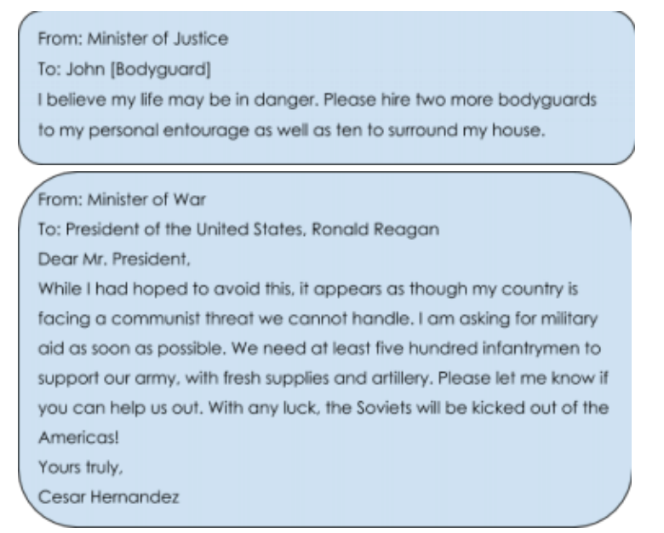

- Final Notes

Award Policy

At the end of the conference, recognition awards will be given to those delegates that had a distinguished participation throughout the three day span of the session. There will be three titles awarded per committee, each recognizing a different aspect of a delegate’s work. In order to be eligible for an award delegates must turn in both position papers before the start of the first session as a final due date.

Research: The research award acknowledges the delegates’ use of knowledge surrounding both issues in committee to provide significant contribution to the debate. This delegate should display knowledge about their delegation’s country policy as well as relations and conflicts with other nations in the committee surrounding the issues being discussed. The quality of the individuals research should be displayed throughout the debate sessions as well as being evident in their position papers.

Diplomacy: The diplomacy award will be granted to a delegate that made a meaningful contribution in the committee by bringing out the best in others. The recipient of this award will not only demonstrate leadership in the debate but will contribute to the work of other delegates and encourage them to voice their position on the topic at hand. This delegate will display cooperative intentions and will look for a consensus within the committee to resolve the conflict being presented.

Best Delegate: The individual awarded with the title of best delegate should embody the qualities from both the diplomacy and research award, having a noticeable and positive contribution to debate throughout the course of the three conference days. The best delegate should inspire and motivate others to do their best.

